Nutrients Management For Crops

Sanskruti Bhise

*Computer Engineering Vishwakarma Institute of Information*

*Technology*

Pune,India sanskruti.22110280 [@viit.ac.in](mailto:ankita.22110173@viit.ac.in)

Punam Navale

*Computer Engineering Vishwakarma Institute of Information*

*Technology*

Pune,India [punam.22110886@viit.ac.in](mailto:punam.22110886@viit.ac.in)

Sakshi Bhos

*Computer Engineering Vishwakarma Institute of Information*

*Technology*

Pune,India

[sakshi.22110330@viit.ac.in](mailto:sakshi.22110330@viit.ac.in)

Prof. Vikas Maral

*Vishwakarma Institute of Information Technology*

Pune,India .

Pranali Mind

*Computer Engineering Vishwakarma Institute of Information*

*Technology*

Pune,India [pranali.22110338@viit.ac.in](mailto:pranali.22110338@viit.ac.in)

*Abstract*— Agriculture is a vital aspect for a nation in determining its overall progress among the other nations. Agriculture remains one of the main fields where technological developments are greatly valued, even with the advent of the technology era. Precision agriculture is a promising solution to global agriculture challenges, enhancing productivity and mitigating environmental impact. Farmers must understand the nutrient composition of the soil in order to produce crops efficiently and apply fertilisers to the soil in the proper ratios. As a result, determining the soil nutrient analysis has become essential in today’s society.

This study investigates the complex relationship between environmental factors and cropperformance using empirical data from several agricultural contexts.

Through the advancement of precision agriculture, robust and sustainable food production systems are supported by this research. By providing farmers with scientific expertise and cutting-edge technology, it ensures food security for coming generations.

General Terms IOT – Internet of Things

Keywords:Machinelearning,algorithms, application, logistic regression, random forest, naïve bayes, Decision tree,SVC.

I. Introduction

About two thirds of workers in African countries are employed in agriculture, which is a

major economic sector, according to the Food and Agriculture Organisation of the United

Nations (FAO). Africa’s agriculture needs to be reformed if poverty, hunger, and malnutrition

are to be eliminated. However, the agricultural industry faces challenges as a result of

climate change, including altered rainfall patterns, droughts, floods, and the development of

pests and diseases that reduce crop productivity[2].

Precision farming has become the focus of agriculture in an effort to meet the world’s food demands while lessening its pollution. This method takes a sophisticated approach,acknowledging that the best crop management takes into account environmental elements that affect crop performance in addition to nutrient supplies. The way farms and agricultural operations are conducted today is very different from how they were conducted several decades before. This is mostly because to technological improvements in the form of sensors, devices, machinery, and knowledge technology. Modern agriculture routinely makes use of cutting-edge technologies like GPS, drone photography, temperature and

moisture sensors, robotics, and numerous intricate IOT gadgets[1].

Crop nutrient management is being revolutionised by the combination of NPK content with

environmental parameters like as temperature and humidity. By analysing large datasets from many geographies and crop types, researchers can gain empirical knowledge on the intricate interaction between environmental variables and crop performance. This is made possible by advanced technologies such as machine learning, IoT devices, and remote

sensing.

In order to accurately forecast crop outcomes under varying climatic conditions, researchers

are creating predictive algorithms to uncover latent patterns and correlations in datasets. These models have the potential to improve fertiliser application efficiency and reduce the effects of climate variability in agriculture by enabling real-time decision-making. The goal of the research is to provide farmers and other stakeholders with the means to improve farming systems’ sustainability, profitability, and productivity all over the world.

II Methodology

**Dataset Description:** The dataset contains information on ten distinct crops, such as crop type, nitrogen (N), phosphorus (P), potassium (K) levels measured in parts per million (ppm), temperature (°C), and humidity. The data were gathered from agricultural research databases and field observations.

**Data Preprocessing:** This step included addressing missing values, eliminating duplicates from the dataset, and cleaning it. Using correlation analysis and domain expertise, feature selection was carried out to find pertinent characteristics. For increased efficiency, aspects that were unnecessary or redundant were eliminated. Normalizing numerical characteristics led to increased performance and homogeneity.

**Model Integration**: Model creation was carried out using the Random Forest algorithm, a decision tree-based ensemble learning approach. The dataset was partitioned into training and validation sets using stratified sampling. The Random Forest model was trained in Python using tools such as scikit-learn, and hyperparameters were tweaked using approaches such as grid search and random search. Cross-validation techniques were used to evaluate performance parameters such as accuracy, precision, recall, F1-score, and area under the ROC curve (AUC-ROC).

**Integration with IoT Sensor Data**: Internet of Things (IoT) sensors were installed to monitor soil nutrient levels (N, P, and K) as well as environmental factors (humidity, temperature) in real-time. Continuous transmission of sensor data to a cloud platform or central server was required for data collection. To forecast crop compatibility, real-time sensor data were combined with the Random Forest model that had been trained. The format and scale of the training data were matched by the processing of incoming sensor data.

**Prediction and Decision**: Using incoming sensor data, the integrated model was used to forecast crop suitability in real-time. Farmers now have access to tips for nitrogen management and crop compatibility forecasts thanks to an intuitive application or user interface. Making well-informed decisions was made easier when forecast results were shown.

**Validation and Performance Evaluation:** Field trials were done to evaluate the integrated model's accuracy and efficacy in realistic agricultural contexts. The performance assessment includes comparing anticipated crop suitability to actual crop performance and yield. Continuous monitoring and assessment of the model's performance was carried out throughout time, taking into account aspects such as predicted accuracy and user input.

The model was iteratively refined based on feedback from field experiments and user experience. Hyperparameters and feature selection were refined to improve model resilience and accuracy. Farmers and agricultural professionals provided feedback to fix the model's limits and weaknesses.

**Components:**

* Capacitive Soil Moisture Sensor
* Soil NPK Sensor
* NRF2401 Wireless Transceiver Module
* ESP32 WiFi Module
* Mobile phone or PC system
* DS18B20 Waterproof Temperature Sensor
* 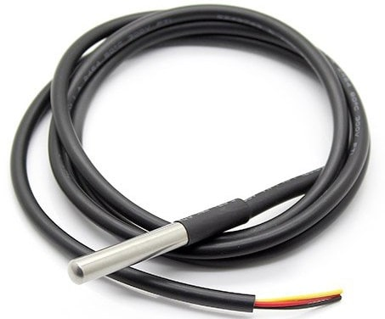Arduino board

waterproof temperature sensor ds18b20

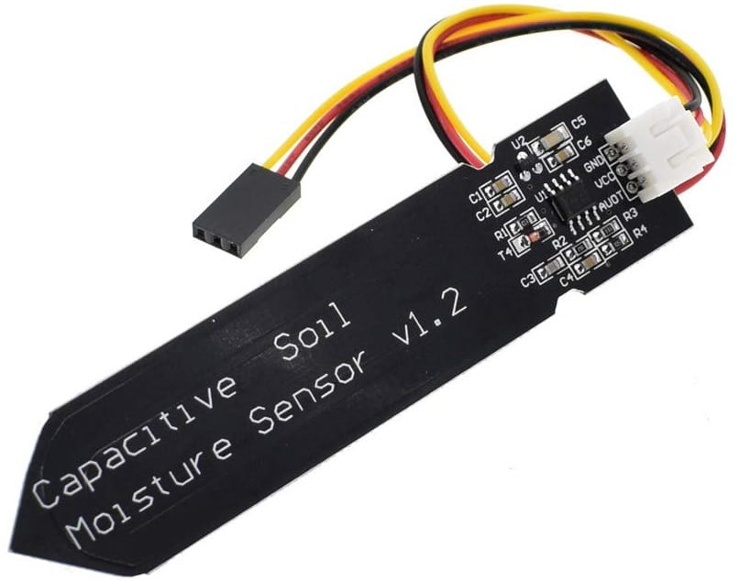

Capacitive soil moisture Sensor v1.2

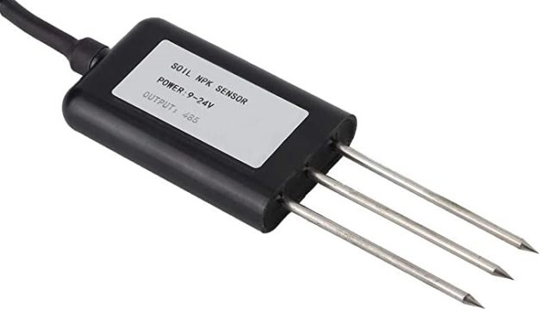

#### 

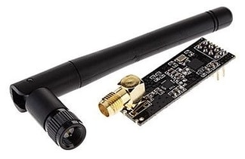 **Soil** NPK Sensor

[**nRF24L01**](https://www.sparkfun.com/datasheets/Components/nRF24L01_prelim_prod_spec_1_2.pdf) is a wireless **transceiver module**

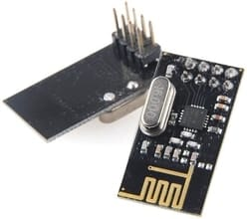

**Functionality:**

**Soil Moisture Monitoring:** To determine the amount of moisture in the soil, use the capacitive soil moisture sensor.

**Monitoring Soil Temperature:** To measure the temperature of the soil, use the DS18B20 Waterproof Temperature Sensor.

**Monitoring Soil Nutrients:** Use the Soil NPK Sensor to determine the amounts of soil nitrogen, phosphorus, and potassium (NPK).

**Data Transmission:** To transfer sensor data wirelessly from the sensor node to the gateway, use the NRF2401 Wireless Transceiver Module.

**Data Reception:** Utilizing the ESP32 WiFi Module, which has access to a WiFi network, receive the transmitted data**.**

**Data Visualization:** Upload the gathered data to the ThingSpeak server and watch it visually and quantitatively.

**Remote Monitoring:** Use a mobile phone or computer to access monitored data remotely.

**Implementation:**

Connect all sensors to the Arduino board.

Use Arduino code to read sensor data and send it wirelessly via the NRF2401 module.

Configure the ESP32 WiFi module to accept data from the NRF2401 module and upload it to the ThingSpeak server.

Access the monitored data on a mobile phone or PC system via the ThingSpeak platform.

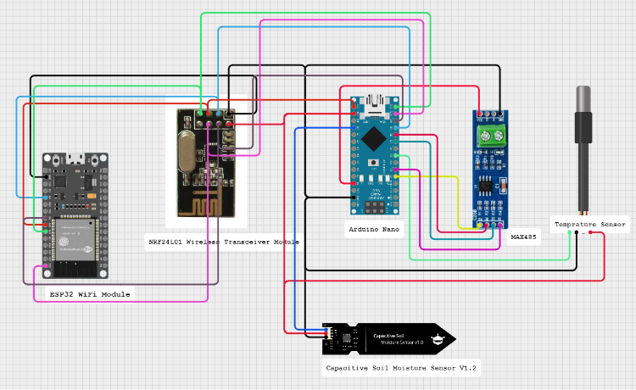

Fig.1

IV. Algorithm

Random Forest is a supervised machine learning technique applicable to both Classification and Regression problems. It operates on the principle of ensemble learning, wherein multiple classifiers are combined to address complex problems and enhance model performance.

The RF classifier is an ensemble approach that trains many decision trees simultaneously with bootstrapping, followed by aggregation, often known as bagging. Bootstrapping means that numerous distinct decision trees are trained in parallel on different subsets of the training dataset with varying sets of accessible features. Bootstrapping guarantees that each decision tree in the random forest is unique, lowering the overall variance of the RF classifier. The final conclusion is made by aggregating the decisions of various trees; as a result, the RF classifier demonstrates strong generalization. The RF classifier outperforms most other classification algorithms in terms of accuracy while avoiding overfitting. Like the DT classifier, the RF classifier does not need feature scaling. Unlike the DT classifier, the RF classifier is more resilient to training sample selection and training dataset noise. Compared to the DT classifier, the RF classifier is more difficult to comprehend but easier to tweak the hyperparameters.

Random Forest offers robustness by reducing overfitting through the averaging of predictions from multiple trees. It is versatile, being effective for both classification and regression tasks, and provides insight into feature importance for interpretation.

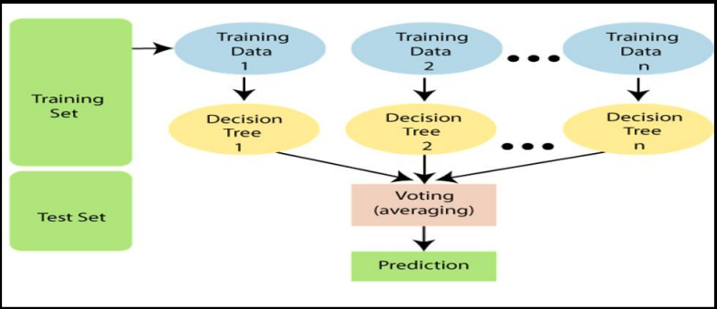Applications of Random Forest include image recognition, spam detection, sentiment analysis for classification tasks, and sales forecasting, stock price prediction, and housing price estimation for regression tasks.

Fig.2

**Classification Report:**

**Accuracy:**

Accuracy is a classification problem metric that indicates the percentage of correct predictions. We compute it by dividing the total number of predictions by the number of correct predictions. This formula provides a simple definition based on a binary classification problem. (In the second part of this article, we discuss multiclass and multilabel problems.) In the case of binary classification, accuracy can be expressed as True/False Positive/Negative values.

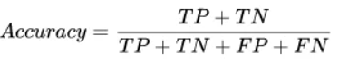

**F1-Score :**

It is traditionally defined as the harmonic mean of precision and recall. It's also known

as the F Score or the F Measure. In other words, the F1 score conveys the balance

between precision and recall. It is thought to be a better measure than Precision and

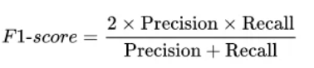

**Precision :**

Precision is defined as the fraction of positive examples that are actually positive among all positive examples predicted by us. It can also be defined as the number of true positives divided by the total number of true positives plus false positives. False positives occur when the model incorrectly labels something as positive when it is actually negative, or in our case, when the model incorrectly labels someone as a terrorist when they are not.

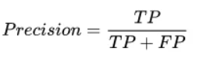

**Recall :**

In statistics, the metric our intuition tells us we should maximise is known as recall, or a model's ability to find all relevant cases within a dataset. The number of true positives divided by the number of true positives plus the number of false negatives is the precise definition of recall. True positives are data points classified as positive by the model that are actually positive (meaning they are correct), whereas false negatives are data points classified as negative by the model that are actually positive (meaning they are correct) (incorrect)

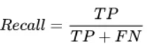

V. Literature Review

The application of IoT technology in agriculture has received a lot of attention in recent years because of its potential to disrupt traditional farming practices. Numerous research have investigated the application of IoT-based systems for soil nutrient monitoring and analysis in order to increase crop yield and sustainability.

Singh et al. (2018) created an IoT-based soil monitoring system using wireless sensor networks to evaluate soil moisture, temperature, and pH levels. The system enables real-time monitoring of soil conditions, allowing farmers to make appropriate irrigation and fertilization decisions, resulting in higher agricultural yields.

Similarly, Khan et al. (2019) suggested an IoT-based smart agriculture system that monitors and manages soil nutrients. The system combined a variety of sensors, including soil moisture, pH, and nutrient sensors, with a wireless communication module to gather and send data to a central server. Machine learning algorithms were used to analyze the acquired data and give farmers with actionable recommendations into efficient nutrient management.

Guo et al. (2020) took a different approach, developing an IoT-based precision agriculture system that employs unmanned aerial vehicles (UAVs) outfitted with multispectral sensors to monitor soil nutrient levels and crop health. The UAVs captured high-resolution imagery of agricultural areas, which was then processed using machine learning algorithms to determine soil nutrient deficits and guide targeted fertilizer application.

VI. Result

The accuracy comparison of five machine learning models for nutrient management in crop cultivation is presented in Figure . The models evaluated include Decision Tree, Naive Bayes, Support Vector Classifier (SVC), Logistic Regression, and Random Forest.

Random Forest outperformed all other models with an accuracy of 98,33%. Following Random Forest, SVC closely followed with an accuracy of 96.11%.Decision Tree achieved the accuracy at 95.2%. Logistic Regression and Naive Bayes achieved accuracies of 92.8% and 98% respectively, ranking among the models evaluated.

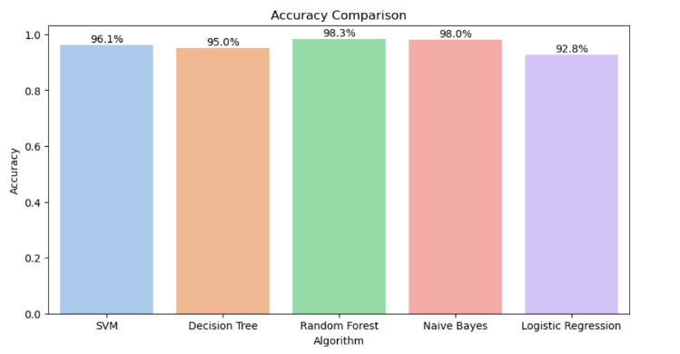

Fig.3 *Accuracy Comparison Graph*

VII. Future Scope

The future of nutrient management involves enhancing spatial and temporal resolution by incorporating satellite imagery, drone technology, and remote sensing data. Advanced machine learning techniques like deep learning and ensemble methods will improve predictive performance across diverse agricultural contexts. Economic considerations will be integrated into models to optimize yield and profitability. Collaboration with stakeholders across the agricultural value chain will ensure widespread adoption and foster innovation within the agricultural community.

VIII. Conclusion

Machine learning techniques can enhance sustainable agriculture by optimizing crop selection, fertilization strategies, and resource allocation through predictive models, thereby improving productivity, profitability, and environmental stewardship, by leveraging data-driven approaches.

Machine learning-based nutrient management models, combining diverse datasets, advanced algorithms, and stakeholder engagement, have the potential to revolutionize agricultural practices and tackle issues like food security, climate change, and natural resource conservation. Continued innovation and collaboration can lead to a more resilient, equitable, and sustainable food system.

IX.Reference

1. <https://www.researchgate.net/publication/346627389_Crop_Recommendation_System>
2. <https://link.springer.com/article/10.1007/s00521-023-09391-2>
3. <https://www.researchgate.net/publication/371589787_Smart_Farming_Crop_Recommendation_using_Machine_Learning_with_Challenges_and_Future_Ideas>
4. <https://www.researchgate.net/publication/357759181_Crop_prediction_using_machine_learning>
5. <https://youtu.be/nh5x_H_lIko?si=K09hOcJceefWsYVj>
6. [https://how2electronics.com/iot-based-soil- nutrient-monitoring-with-arduino-esp32/](https://how2electronics.com/iot-based-soil-%20%20%20%20%20%20%20%20%20%20%20%20%20%20%20%20%20%20%20%20%20%20%20%20nutrient-monitoring-with-arduino-esp32/)
7. Nikolaos Monokrousos and Snezhana MourouzidouEnsuring Plant Nutrition through Sustainable SoilManagementStrategies: Assessing Research Progress and Challenges

[8] SR Juhi Reshma, Dr D John Aravindhar.A Systematic Approach of Classifying Soil & Crop Nutrient Using Machine Learning Algorithms

9] Machine learning in nutrient management Oumnia Ennaji a,b Leonardus Vrgütz a Achraf El Allal